Lab 12
Logging and Network Monitoring
Objective:
The purpose of this lab is for the student to understand the benefits of syslog and network monitoring via SNMP.
Diagram:
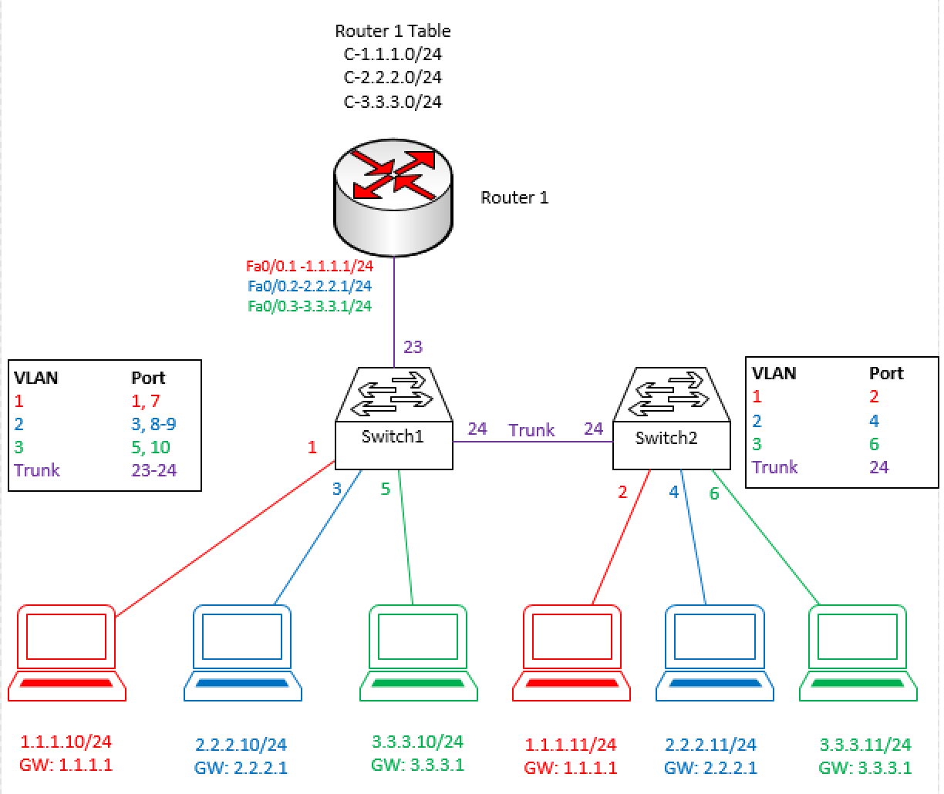
Components:
6 – PC’s with an Ethernet NIC
1 – Router
2 – Layer 2 Switches
Procedure:
- Connect all PC’s together and put their static IP addresses, subnet masks and gateways on them.
- Configure switch ports for access and the correct VLAN for each L2 switch port that which a PC connects.
- Configure trunk ports for the inter-switch ports and the router port.
- Put IP addresses 1.1.1.2/24 on VLAN 1 with a 1.1.1.1 gateway on switch 1 and 3.3.3.2/24 on VLAN3’s interface with a 3.3.3.1 gateway on switch 2. Switch 2 will not have an IP on VLAN1’s interface. Remember, L2 switches can only have a single management IP.
- Configure router on a stick on the router as per the diagram. What does the routing table look like at this point? Paste below:
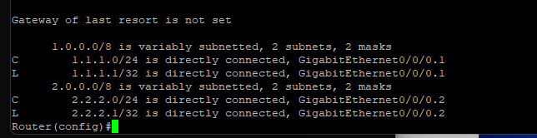
- Does ping work from 1.1.1.10 to 1.1.1.1? Yes
- Does ping work from 1.1.1.10 to 3.3.3.10? Yes
  - Both should be successful before moving on.
- Install Kiwi Log server on your 1.1.1.10 PC if it’s not already loaded. Launch the .exe on the USB drive provided by the instructor. Accept all defaults during the installation. There’ll be a prompt for installing .NET framework 3.5 or later. Please install this. If it’s already installed, move forward to the next step.
- Confirm your “server” is listening on port UDP/514. This is the default syslog port. Screen shot the output of your netstat -a showing LISTENING for UDP 514. Paste Below:
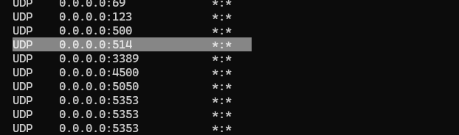
- Configure both switches for logging. Set the log server to 1.1.1.10. Let the logging trap level to informational. Enable logging.
- Connect to your switch 1 and shut down the PC with IP 2.2.2.10. The log should show up on your screen and on the Kiwi log server. Do the same for the PC with IP 2.2.2.11. Paste the logs below:
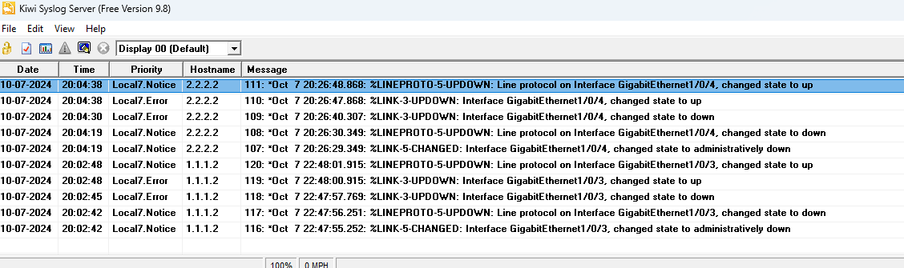
- Connect to the router via console. Enter the same commands to enable logging on the router as done on the switch. Since both devices use IOS as their operating system, the commands are the same in most cases. Enter the following additional command: logging source-interface fastethernet 0/0.3
- Do a “no shutdown” for interface Ethernet 0/0. Wait 10 seconds and then shut the port back down.
- The logs should show up in Kiwi. What IP address shows as the source of the logs? 1.1.1.2; Paste the logs below.
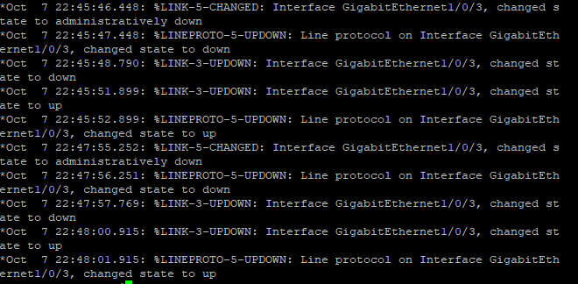
- Install PRTG server on your 1.1.1.10 PC if it’s not already loaded. Launch the .exe on the USB drive provided by the instructor. Accept all defaults during the installation. If it’s already installed, move forward to the next step.
- Open Chrome and go to http://localhost. This should launch the PRTG Web GUI (graphical user interface).
- There should be some default sensors installed that show statistics and current state of the server. These objects are under the “probe device” menu. Screen shot and paste below the health of your probe device. Click on the following and enter the values for your probe device:
  - Core Health: 100 %
  - Disk Free: 66 %
  - CPU Load 3 % Click on system health to get this
  - Memory Available 35 % Also in System health
- Next, configure SNMP on switch 1 using the commands from the notes. Your community string should be Netcom2, your server should be 1.1.1.10 and the Version should be 2c. What commands did you use? Paste below:
Snmp-server source-interface informs gigabitEthernet 0/0/0.2
Snmp-server source-interface traps gigabitEthernet 0/0/0.2
- Now let’s go back to the PRTG GUI. Right Click on Local Probe and click “add group”.
- Call the group “Cisco Devices”. Click Add. The group should show near the bottom of your list. If it doesn’t, try hitting the browser refresh button or F5 at the top of your keyboard to refresh the screen.
- Click the “Add Device” Button for your Cisco Devices group. For the name, enter Lab12Switch1. Enter the IP for switch 1 in the IP field. Scroll down and deselect the inherit button bellow “Credentials for SNMP Devices”. This will allow you to enter your info for this device. Use the following info:
  - Community String: Netcom2
  - Version: 2c (default)
  - SNMP Port 161 (default)
  - SNMP timeout: 5
  - Click Ok
- Once the device is shown in PRTG, click the “Run Auto discovery” button next to the device. Let the process finish. Screen shot the list of probes that were discovered for your device and paste below:
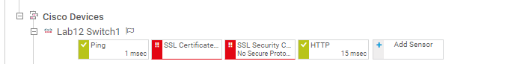
- Do the same process for Switch 2. Paste the list of probes below:
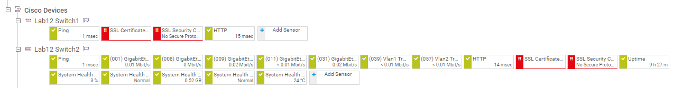

- Connect to the router and enter the same SNMP credentials and commands. Add the following to the router:
  - snmp-server source-interface fastethernet 0/0.2
  - What do you expect this command to do?
The source of the SNMP messages is set to GigabitEthernet0/0/0.2, so it will check the IP 2.2.2.1.
- Add the router to PRTG using its fa0/0.2 interface IP and the SNMP credentials configured in the previous step. Run auto discovery on the router and screenshot the probes below.
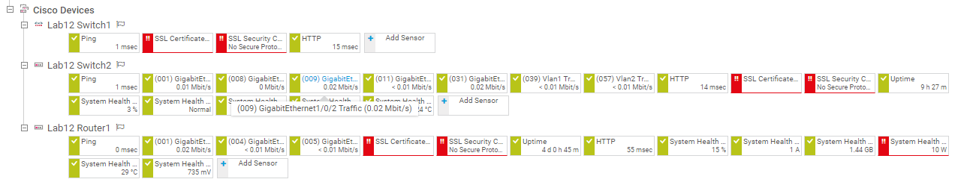
- Create the lab diagram below (PCs, router and switch connections) in Packet Tracer or Visio. Label the IP addresses, subnet masks, and gateways used by each device. Label the routing tables next to the switch and router and the switches vlan IP addresses and port vlan information. Label your syslog and snmp (PRTG) servers so that it’s easy to identify where the services were running.
